**Creating Microservices for account and loan:**

**AccountController.java:**

package com.cognizant.account.controller;

import org.springframework.web.bind.annotation.*;

import java.util.Map;

*@RestController*

*@RequestMapping*("/accounts")

public class AccountController {

*@GetMapping*("/{number}")

public Map<String, Object> getAccountDetails(*@PathVariable* String number) {

return Map.*of*(

"number", number,

"type", "savings",

"balance", 234343

);

}

}

**AccountApplication.java:**

package com.cognizant.account;

import org.springframework.boot.SpringApplication;

import org.springframework.boot.autoconfigure.SpringBootApplication;

@SpringBootApplication

public class AccountApplication {

public static void main(String[] args) {

SpringApplication.run(AccountApplication.class, args);

}

}

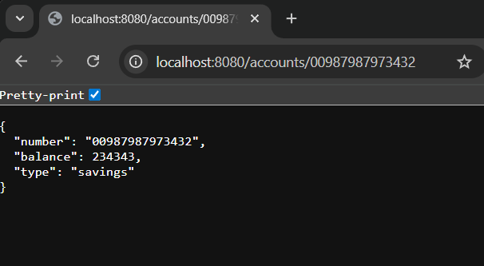

**LoanController.java:**

package com.cognizant.loan.controller;

import org.springframework.web.bind.annotation.*;

import java.util.Map;

*@RestController*

*@RequestMapping*("/loans")

public class LoanController {

*@GetMapping*("/{number}")

public Map<String, Object> getLoanDetails(*@PathVariable* String number) {

return Map.*of*(

"number", number,

"type", "car",

"loan", 400000,

"emi", 3258,

"tenure", 18 );

}

}

**LoanApplication.java:**

package com.cognizant.loan;

import org.springframework.boot.SpringApplication;

import org.springframework.boot.autoconfigure.SpringBootApplication;

@SpringBootApplication

public class LoanApplication {

public static void main(String[] args) {

SpringApplication.run(LoanApplication.class, args);

}

}

